***Create a Windows Serve virtual machine***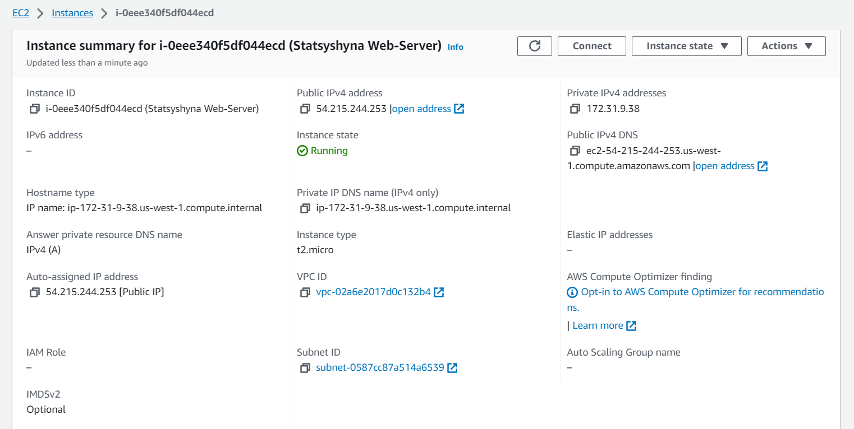

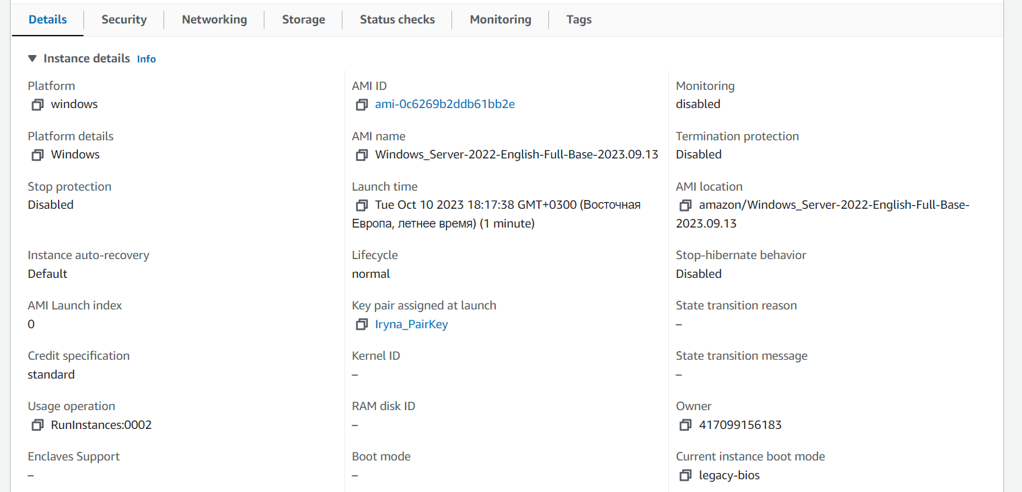

picture 1 - windows “instances”

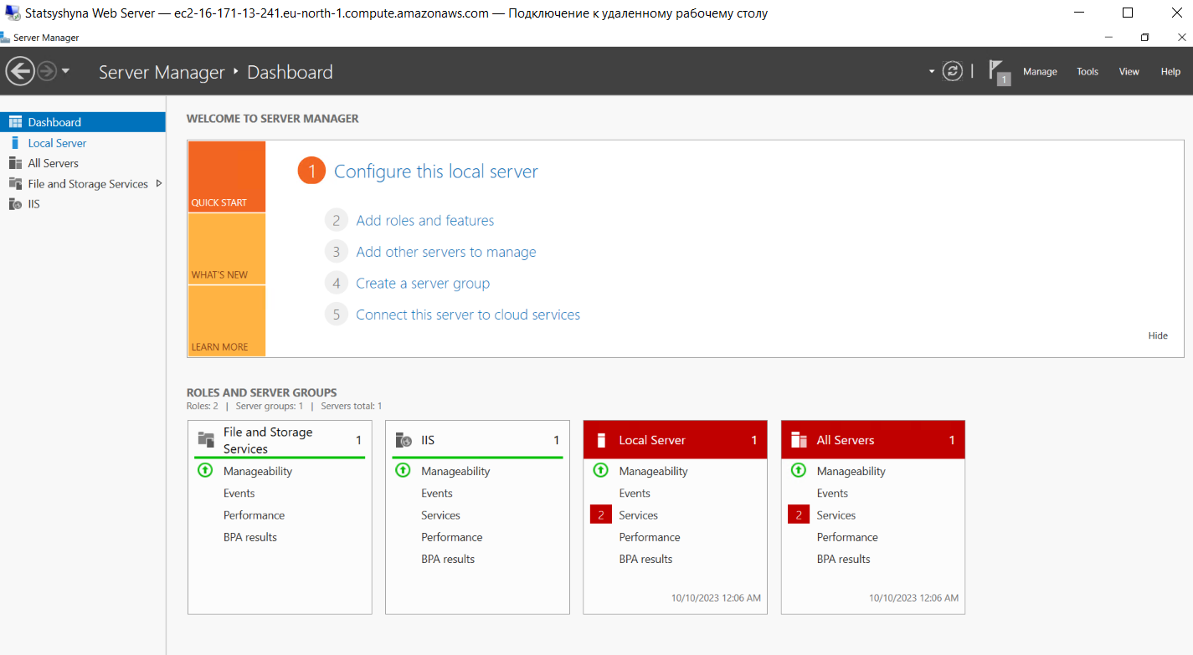

picture 2 – Server Manager on VM windows

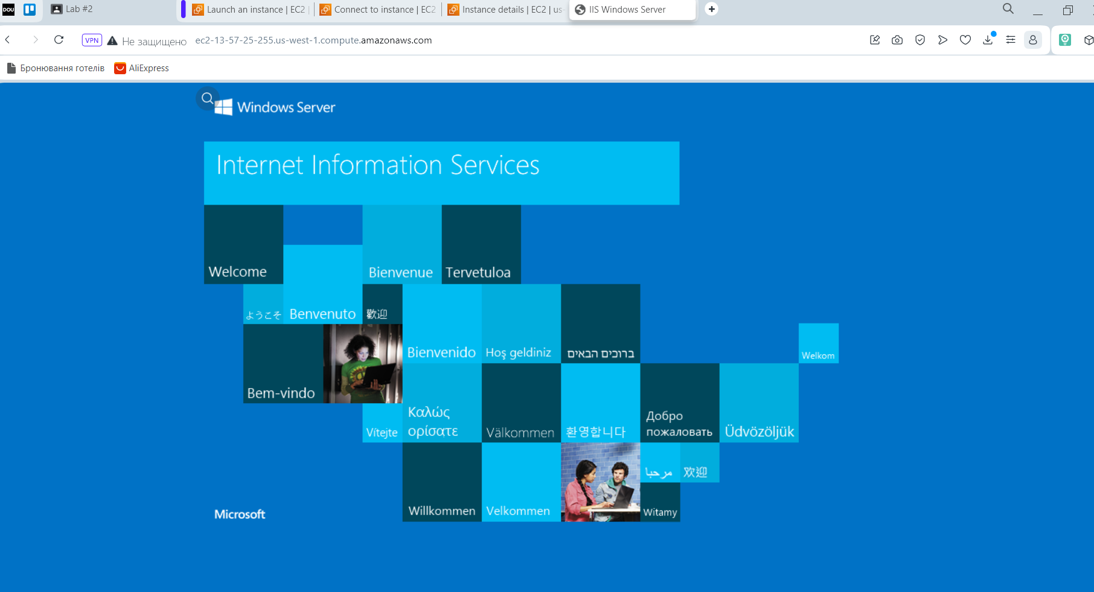

picture 3 – Web site on my windows machine

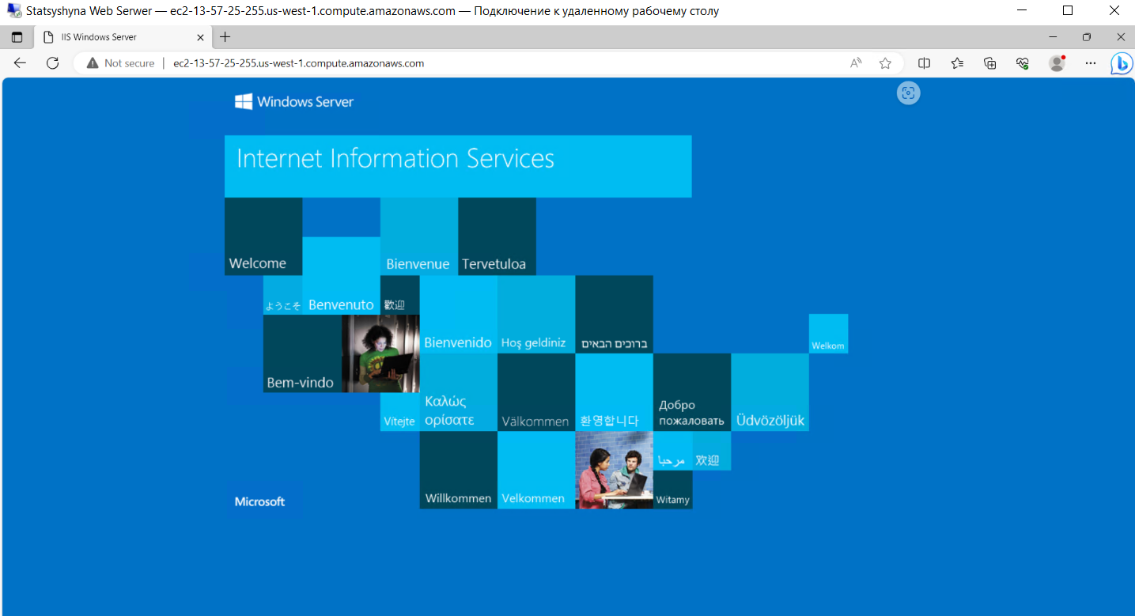

picture 4 – Web site on VM windows

***Creating Linux Ubuntu VMs***

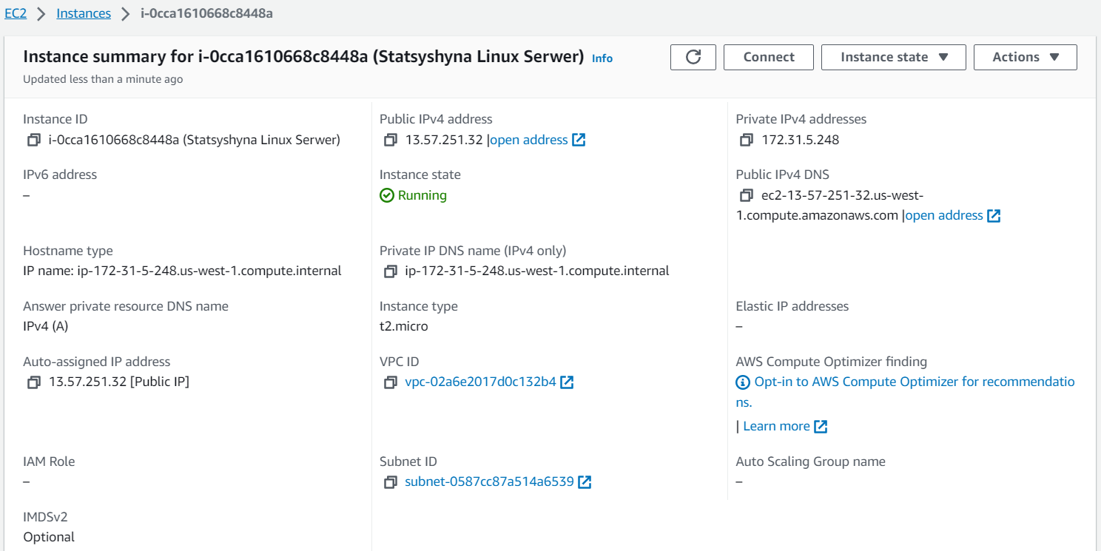

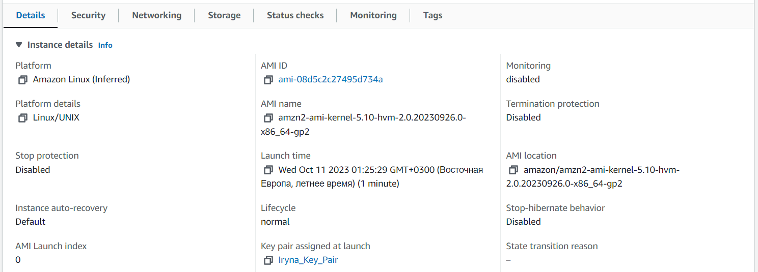

picture 5 - Linux “instances”

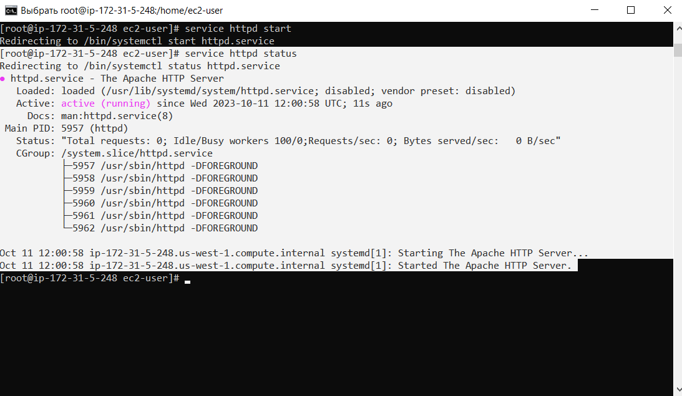

picture 6 - turn on httpd.service

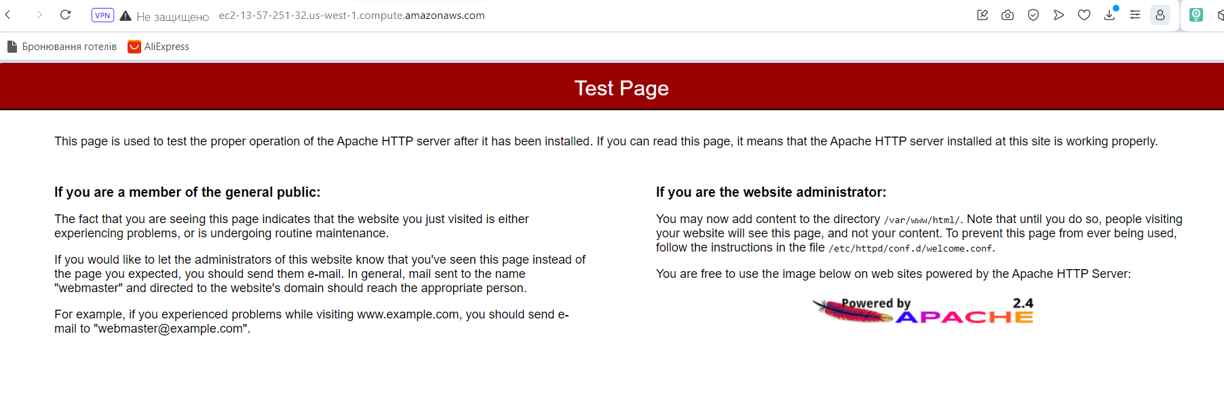

picture 7 – Web site before unpackings

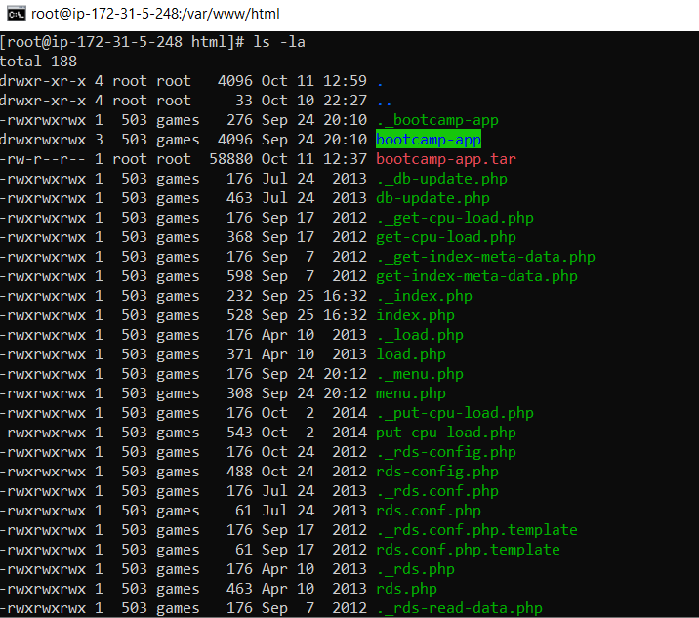

picture 8 – directory with web site

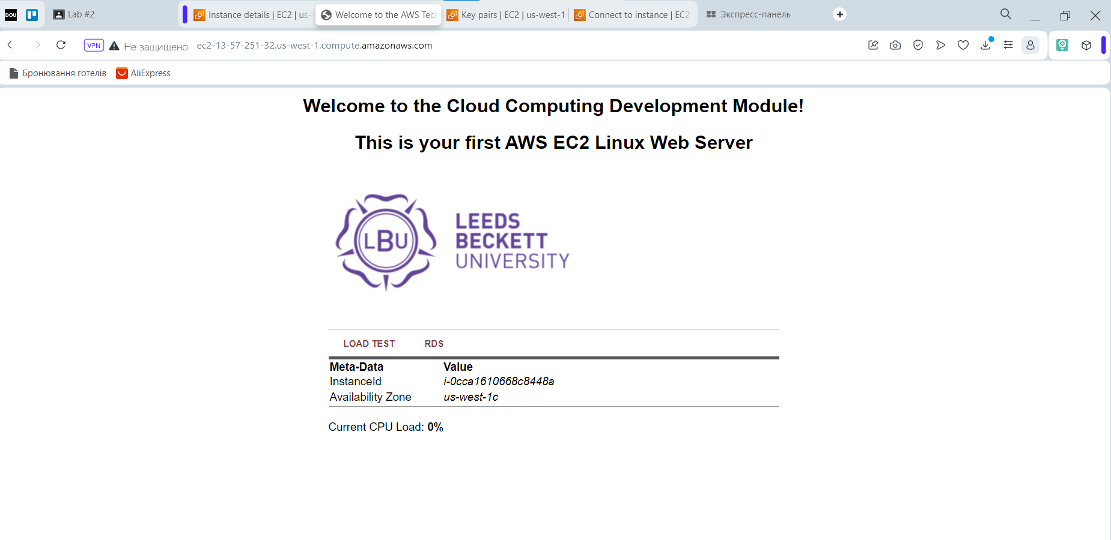

picture 9 – Web site on my machine (Linux web server)

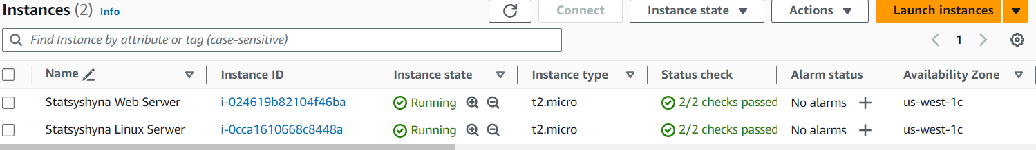

picture 10 – instance before delete

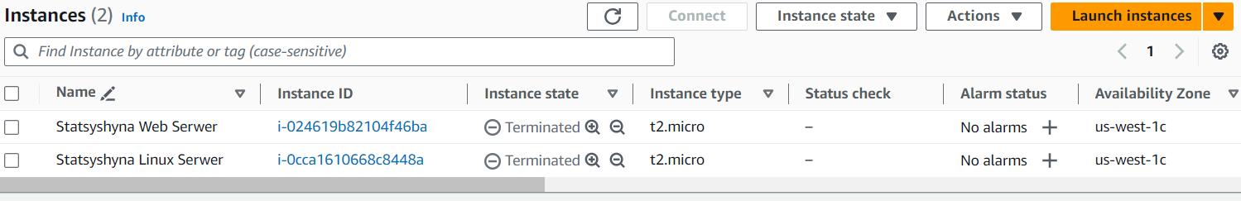

picture 11 - instance after delete